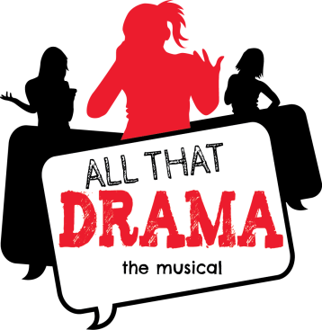

FOR IMMEDIATE RELEASE MEDIA CONTACT: Bruce McKagan
bmckagan@gmail.com

This Is Our Time!
The literary and performing arts communities have joined forces with educators and students from across the southeast to tackle the mounting concerns facing our teenagers each and every day. Forced to deal with the constant threat of bullying, jealousy, lying, haters and hurtful demands, too many of our teens feel trapped with no way out.

ALL THAT DRAMA was the brain child of author, motivational speaker and educator, Kimberly P. Johnson and music industry executive producer and composer, Bruce McKagan.

“Searching for the most effective ways to connect with teenagers, we quickly discovered that music, poetry, social media and one-on-one dialogue were the answers,” says Kimberly. “I got the ball rolling by writing a book of poems called ALL THAT DRAMA that deals with real issues faced by our teens. Next I called on my friend and music industry veteran Bruce McKagan, and he reached out to producer Joe Carter and their huge network of musicians, composers, rap artists and vocalists to help write and produce tracks that speak directly to our teens. Our works morphed into a musical, as we solicited the support of members of the performing arts in dance, theater and drama. Then I tap on the shoulder of my education community. They inspired me to create class room lessons we call ‘the chat lab’, showing pre-teens, teens, teachers and parents how to enter into open dialogue about this sensitive subject.

Bruce continues, “We call it ALL THAT DRAMA the collection. Through it all… the poetry, music, theater, class room and novel… our message remains the same. Acknowledge teenager’s daily struggles and face them head-on. Then discover ways to rise above ALL THAT DRAMA.”

“This is our time,” says Kimberly. “Time for our literary, performing arts and education communities to bond together to do all we can to help our kids!”

The release of ALL THAT DRAMA the music is set for December 10, 2013, with the World Premiere of ALL THAT DRAMA musical scheduled from January 9-12, 2014 at South Pointe High School in Rock Hill, SC.

For release dates, event tickets and more information go to www.allthatdrama.com

About Simply Creative Works:
A Carolina company founded by Kimberly P. Johnson that promotes, distributes and manages her many products and services. As author, motivational speaker and educator, Simply Creative TM provides an array of Kimberly’s services, including motivational speaking engagements, book sales and signings, and educational workshops for writing, reading, staff development and parents. For more information go to www.smplycreativeworks.com

