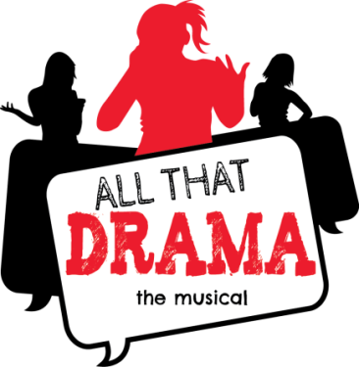

FOR IMMEDIATE RELEASE MEDIA CONTACT: Bruce McKagan
bmckagan@gmail.com

Music Execs Discover Drama in Fort Mill
FORT MILL, SC - When former Muzak executive Bruce McKagan moved himself and company from Seattle to Fort Mill in 2000, little did he know what would happen 13 years later. Joe Carter, award winning producer and founding member of Columbia recording artist Joe Public, had no idea that when he relocated from New York to Fort Mill he would begin to produce music that would change lives.

In December of 2012, Bruce and Joe, who have collectively written and produced nearly 100 music compositions over the last decade, were approached by York County author and nationally acclaimed motivational speaker and educator Kimberly P. Johnson about producing music for a book of poems she had written. It wasn’t long before the creative floodgates opened wide. Over the following nine months ALL THAT DRAMA the musical was born.

ALL THAT DRAMA the musical is a current day story that reveals how a middle class African- American family, the Charles, rely on their deep rooted family values to deal with life’s challenges. From the real world struggles of bullying, lying, drugs, and mental illness, it’s a story that follows 16 year old Whitney Charles and the positive impact she and her family have on the neighborhood, her diverse group of classmates and their new neighbors, the McCarthys, a white, upper-class family.

“When Kimberly introduced Joe and me to her project, we prepared to crank out a few pop tunes… and that would be it. But the more we work together on ALL THAT DRAMA, the more we saw the real impact this music and message could and should have on our kids and our community. One song became five, then an album, and finally a musical with 30 songs. Fort Mill’s own Tommy DeCarlo, lead singer of legendary rock group Boston, and popular rap artist Overflow, soon joined us in Joe’s recording studio along with several other extremely talented high school and veteran artists from the region. Early on we could see that ALL THAT DRAMA the musical was bigger than the three of us,” says co-creator Bruce McKagan.
WORLD PREMIERE: January 9-12, 2014 at South Pointe High School in Rock Hill, SC, award winning drama teacher James Chrismon will direct the first ever stage performance of ALL THAT DRAMA the musical. This hard-hitting dramatic work will feature drama and vocal students from York County School District #3, including lead roles performed by Latashianna Alexander and Kristi Swiger.

Ticket purchase at event only - January 9, 10, 11 at 7PM, January 12 at 2:30PM - $5 students, $10 adults
South Pointe High School - 801 Neely Road, Rock Hill, SC 29730

For more information go to www.allthatdrama.com

About Simply Creative Works:
A Carolina company founded by Kimberly P. Johnson that promotes, distributes and manages her many products and services. As author, motivational speaker and educator, Simply Creative TM provides an array of Kimberly’s services, including motivational speaking engagements, book sales and signings, and educational workshops for writing, reading, staff development and parents. For more information go to www.simplycreativeworks.com

